PROGRAMS ON ARRAYS

- Write a C++ program to find the largest and smallest element of a given array of integers.
Expected Output:
Enter the size of the array: 5
Enter the elements of the array: 10 50 30 20 3
Largest element: 50
Smallest element: 3

- Write a program to find the frequency of a element in an array

(Hint: Here k=2 represents element in the array)
Input:
arr = {1, 2, 3, 5, 2, 9, 7, 3, 5}
K= 2
Output:
- occurs 2 times

- Write a C++ program to separate even and odd numbers of an array of integers. Put all even numbers first, and then odd numbers.
(Hint: Either you can create two arrays for storing odd and even then print them or by using same array u can do it)
Output:
Enter the size of the array you want 8
Enter the elements of the array
56 67 87 54 35 68 80 76
Even numbers of the array are
56 54 68 80 76
Odd numbers of the array are
- 87 35

- Write a C++ program to find kth largest elements in a given array of integers.
Output:
Input: [3,2,1,5,6,4]
k = 2 (Hint: here k=2 represent second largest number in the array)
Output: 5

- Write a c++ Program to Insert an Element in an Array
( Hint: Here input can take sorted or unsorted order as ur wish)
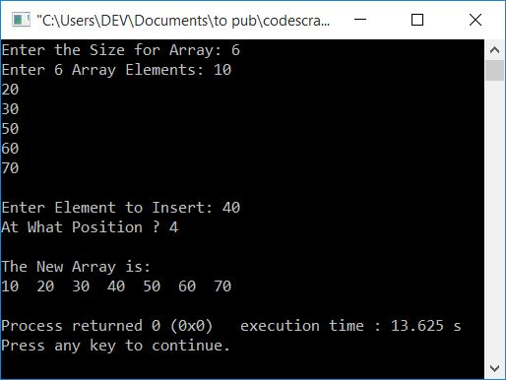

- Write a C++ program to delete an element from an array
(Take the elements into array then sort the elements then ask for the position to be deleted and display the new array)
Sample Output:
Enter Data in Array: 20 30 10 50 40
Stored Data in Array: 10 20 30 40 50
Enter poss. of Element to Delete: 2
New data in Array: 10 20 40 50
- Write a program to read an Array and Search for an Element in the array and display the position of the element.
(Hint: Position of the array should the position of original array only same like in sample output and input can be taken in any order)
Sample Output:
